# Lesson 4, Step 5: Preparing for Your Final Assignment

It's time to tackle your final assignment. Assignment 0.4 gives you the perfect opportunity to showcase everything you've picked up so far on your interior design journey.

## 1. Room Documentation: The Foundation of Your Assignment

### Putting Your Documentation Skills to Work

All those documentation techniques we've been working on throughout the course will now serve as valuable tools for this final project. Similar to how a chef gathers ingredients before starting to cook, you'll need to collect all the visual and spatial details that will shape your design choices.

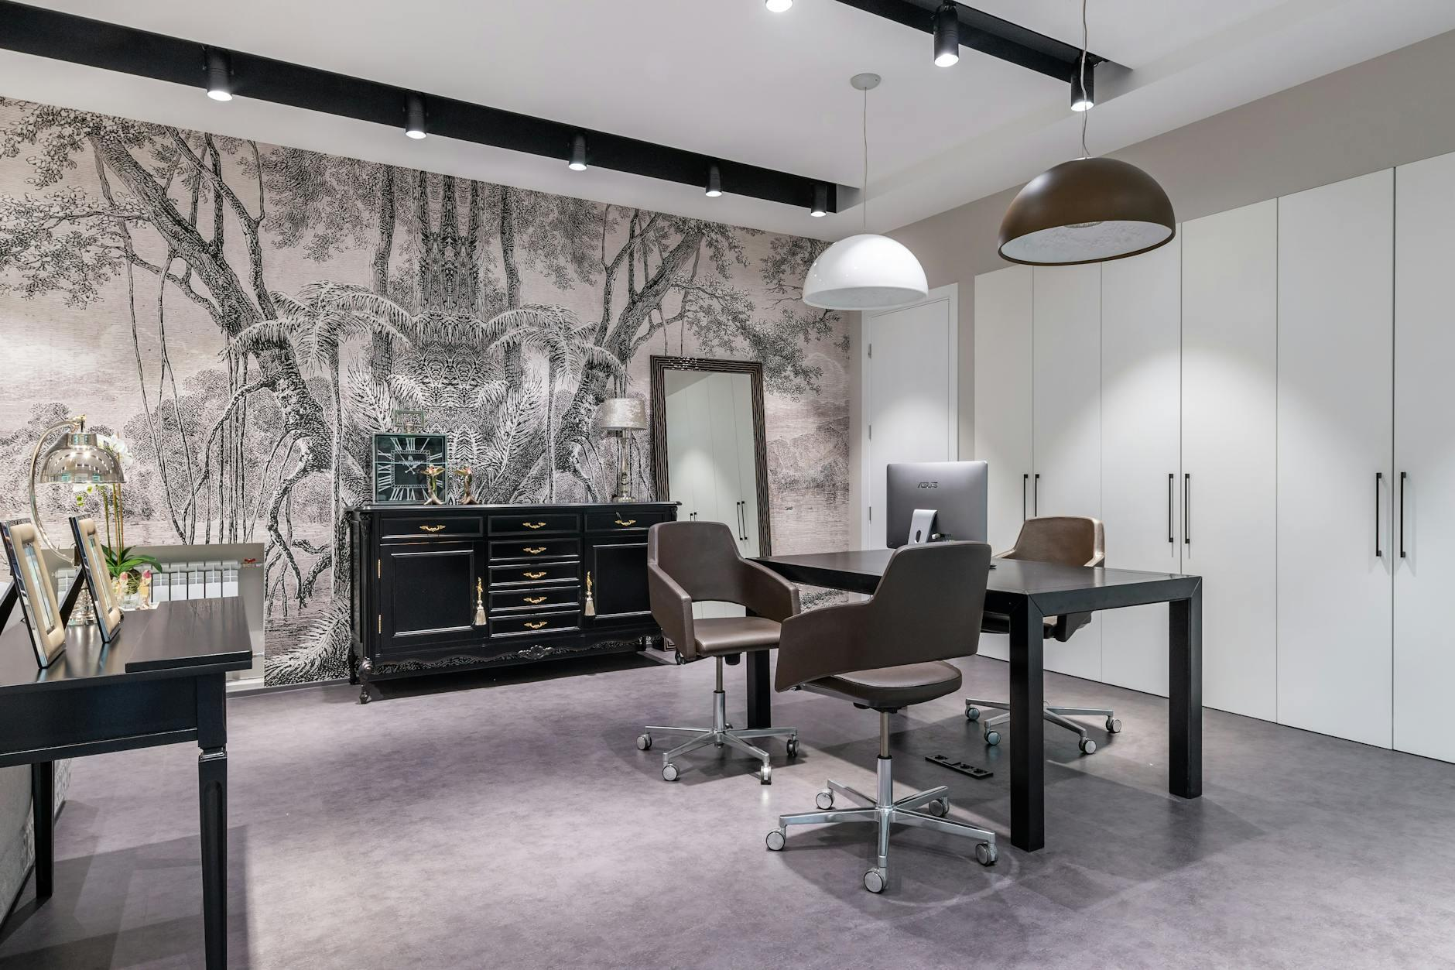

Fig.1 (Max Vakhtbovycn on [Pexels](https://www.pexels.com/photo/7535030/), 2025) Room documentation showing strategic photo angles that capture spatial relationships and natural lighting

* **Photographic Documentation**:
* The angles you select actually tell a story—make sure they highlight what's important in the space
* Consider what someone needs to see to grasp the home office potential
* **Measurement Interpretation**:
* Floor plan measurements aren't mere numbers—they define what's possible
* They'll influence every furniture decision (and help avoid that awkward "it doesn't fit" moment we've all experienced)

**Before your initial client meeting, try this:** Write down what you need to find out from your "client" (friend) during the questionnaire stage. When you look it over, you might realize you almost forgot to ask something crucial—these details often separate good designs from exceptional ones. Put a circle around the three questions you think will give you the most valuable insights. Ask yourself which question might uncover unexpected needs.

## 2. Space Planning for Your Assignment

Here comes the fun part where you'll turn basic square footage into a functional workspace. Space planning is like choreographing a dance—each element needs enough room to serve its purpose while working harmoniously with everything else. Your task is creating a home office that balances productivity with personality.

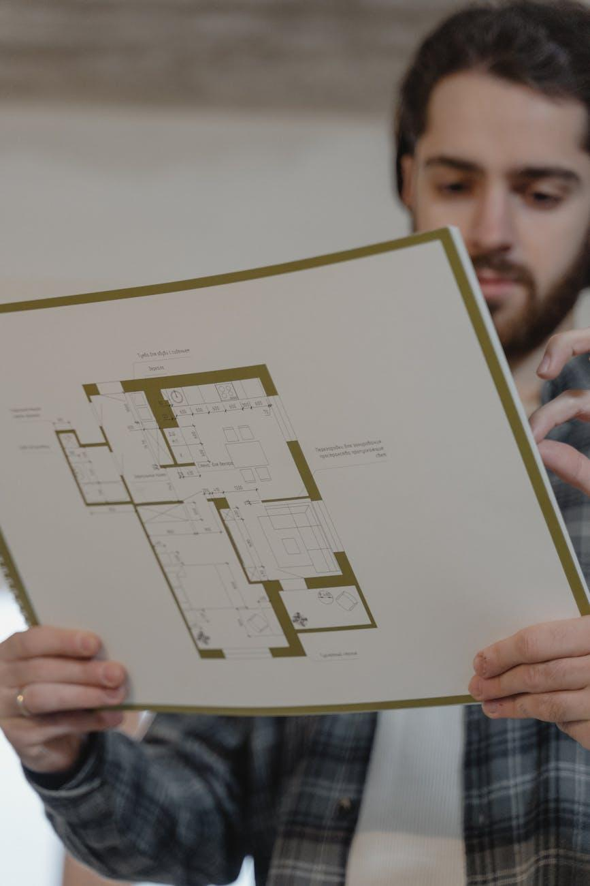

Fig.2 (Tima Miroshnichenko on [Pexels](https://www.pexels.com/photo/6474484/), 2025) Space planning showing zoning approaches and movement paths for a practical home office layout

1. **Zoning Basics**: Think about the natural divisions in the room (where would focus happen? where would storage go?)
2. **Traffic Flow**: No one likes bumping into furniture—map out how people move through the space
3. **Furniture Layout**: Place the essentials with breathing room to function properly

**While evaluating workspace functionality, try this:** A thoughtfully designed home office can completely change someone's daily work experience. As you arrange elements, picture yourself spending eight hours there—would you feel comfortable? Could you reach everything you need? Would you feel inspired or trapped? Quickly sketch a comfort map highlighting potential problem spots. Give each zone a 1-5 rating for both comfort and productivity.

## 3. Client Communication for Assignment 0.4

### Home Office Client Questionnaire

Understanding the person who'll use the space is crucial to any successful design. Your questionnaire isn't paperwork—it's your glimpse into your client's work habits, preferences, and frustrations. The more naturally you can weave these questions into conversation, the better insights you'll gather.



Fig.3 (Photo By: Kaboompics.com on [Pexels](https://www.pexels.com/photo/6255597/), 2025) Client interview showing active listening that builds rapport while gathering key design requirements

* "Walk me through a typical workday—what activities take up most of your time?"
* "When you're in the zone, what do you need within arm's reach?"
* "Do people ever see your workspace during video calls?"
* "What tends to create mess in your current setup?"
* "After working all day, what makes a workspace feel refreshing rather than draining?"
* "Are there any colours or elements that help you concentrate when working?"
* "Which existing pieces have proven their worth and deserve a spot in your new office?"

**When practicing client interviews, try this:** Keep your questions conversational and straightforward. People tend to reveal more about what they need when they're relaxed—and those unexpected insights often lead to the most personalized solutions. Make note of which questions got the most animated responses. Come up with one follow-up question for each enthusiastic answer.

## 4. Assignment Submission Timeline

Let's be honest—creative projects tend to expand to fill whatever time we give them. Breaking your assignment into manageable chunks not only prevents last-minute scrambling but also gives you room to refine your ideas. Think of this timeline as your design roadmap, with each week building toward your final vision.

* **Week 1**: Get to know your client through the questionnaire and document the space
* **Week 2**: Rough out your ideas and experiment with furniture arrangements
* **Week 3**: Lock in your direction and prepare materials that showcase your vision
* **Week 4**: Fine-tune everything before submitting

Add actual dates from your course schedule, and mark when you'll pause for feedback.

**As you develop your project plan, try this:** Where do you typically get stuck? Some designers linger in the idea phase, while others spend ages perfecting presentations. Knowing your tendencies helps you allocate time realistically—and maybe give yourself that buffer day before the deadline. Mark your calendar with personal milestones for each phase. Set one non-negotiable cutoff date for your most challenging stage.

## 5. Design Presentation Elements

Your design might be brilliant, but if you can't communicate it clearly, much of that brilliance gets lost. Think of your presentation as telling a visual story—one that guides your client from understanding the problem to embracing your solution. Each element should build confidence in your vision while addressing their specific needs.

**[Figure Fig 4: No suitable image found]**

[Image: Professional mood board for a home office showing cohesive material samples, colour swatches, furniture images, and inspirational elements arranged on a neutral background. Caption: "Fig 4: Inspiration board showing material combinations and design direction for a productive home office"]

* **Inspiration Board**: This visual collection should:
* Connect with what matters to your client
* Show practical solutions for home offices
* Present a cohesive story about your design approach
* **Materials List**: This document outlines:
* The main materials you're suggesting
* Your colour choices
* The key furniture pieces

**During your creative exploration, try this:** Your inspiration board isn't just a collection of pretty images—it's the first glimpse your client gets of their future space. Those 8-12 carefully chosen images should work together to build excitement and confidence in your vision. Write down in one sentence what story your board should visually tell. Test your board on someone who hasn't heard about your design concept.

## 6. Self-Assessment Preparation

### Looking Back and Forward

The end of any design project isn't just about delivery—it's about reflection. This is where real growth happens. As you finish your assignment, take time to step back and consider not just what you created, but how the process changed you as a designer. These insights will support your continued development.

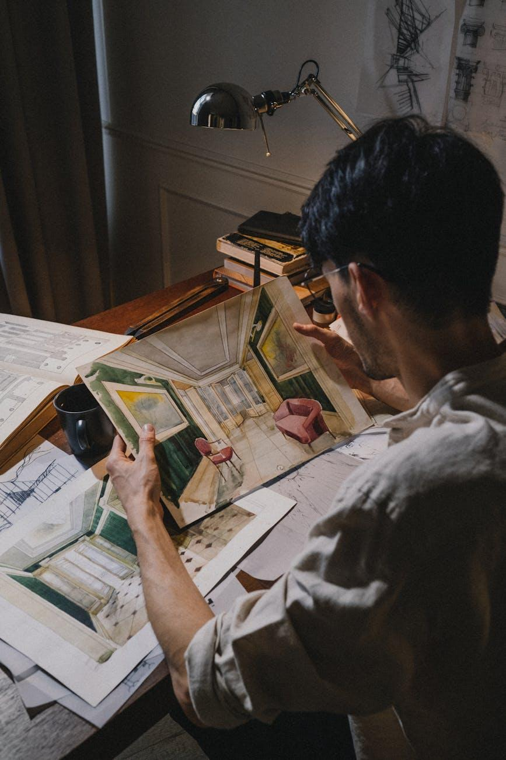

Fig.5 (Ron Lach on [Pexels](https://www.pexels.com/photo/9618113/), 2025) Self-assessment showing a designer's reflection process and notes on growth areas